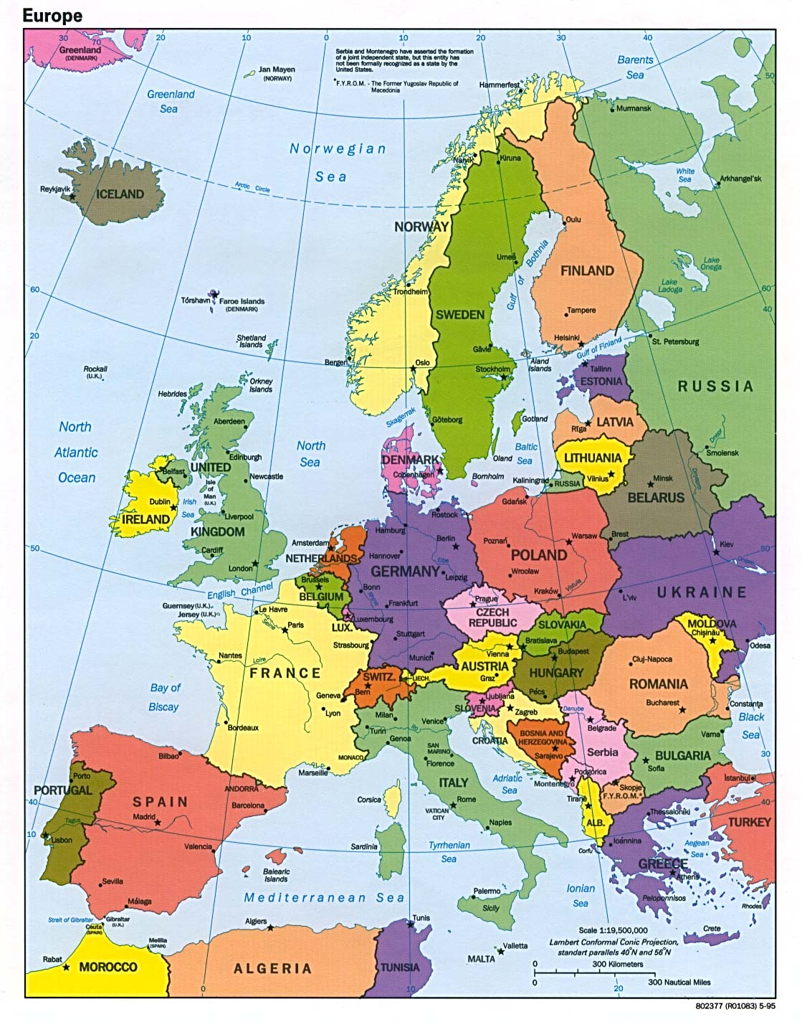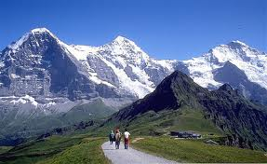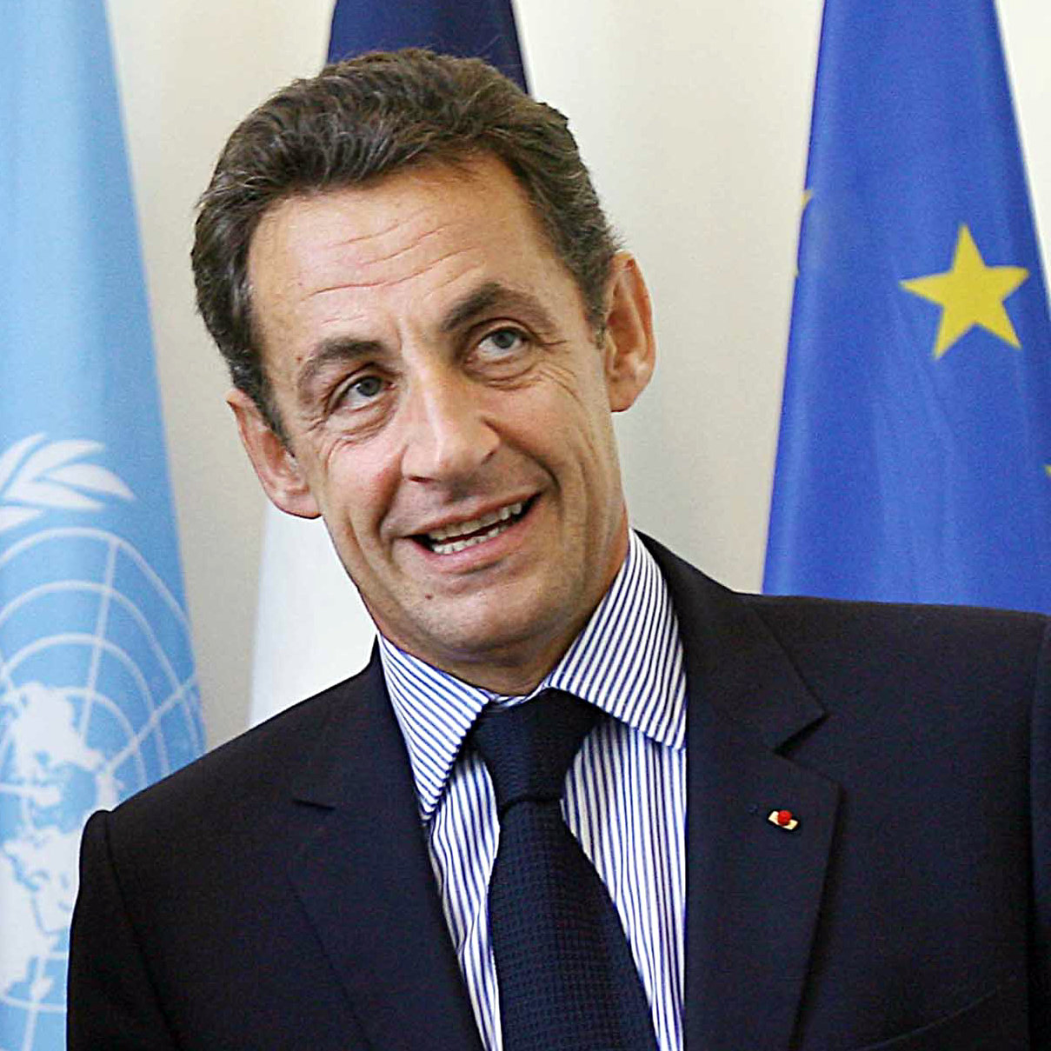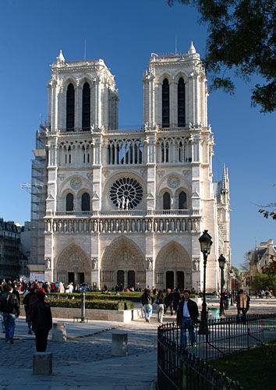

Ms. Pattiz

Power Center Academy

Ms. Pattiz’s 7th grade Social Studies Class

Europe

The Alps are beautiful, but also provided Europe with needed protection.

Europe’s geography is, above all else, extremely diverse. From snowcapped mountaintops, to winding rivers, to vast oceans, Europe’s landforms are beautiful as well as culturally significant. Europe’s major rivers include the **Rhine**, running through Germany, the **Seine**, at the center of Paris, the **Thames**, a centerpiece of London, and the **Danube**, which travels through Eastern Europe. Each of these rivers provides the continent with important resources. Thanks to these rivers, Europe has a constant supply of hydropower for electricity, water for transportation and drinking, and fertile soil in which to grow crops. Rivers, it can be said, are Europe’s lifeblood.

Along with its rivers, Europe has many beautiful mountains, including the **Alps** and the **Pyrenees**. These mountains allow for recreation, like skiing and snowboarding, bringing tourists to the continent. However, they also provided protection to Europeans throughout history. Invaders were unable to cross these high peaks. As a result, European culture could grow and flourish in safety. Europe’s mountains are not only gorgeous, but also practical.

# Geography of Europe

# The Power of the People

Europeans benefit from some of the world’s strongest and oldest democracies. In fact, Greece, a country in Europe, was the birthplace of democracy, as we know it. Virtually all European countries operate under a democratic, either Parliamentary or Presidential, system. For example, in the United Kingdom, Prime Minister David Cameron is elected by Parliament. Parliament is elected by the citizens of the United Kingdom. Though the country has a Queen, she has little power. Individual people have the real power in this country.

France’s government is also a democracy, and the country has a strong history of democracy ever since the French revolution in 1779. President Nicolas Sarkozy is elected by French citizens. If people do not like what he does, they can remove him from leadership and elect someone else. France has no monarch at all, unlike the U.K. In France, individual citizens determine the laws and rules that affect their lives. 

Nicolas Sarkozy is the democratically elected President of France.

Notre Dame Cathedral is located in the center of Paris.

Europe’s governments are secular, which means that they exist separate from religion. That said, many religions exist throughout Europe. The most commonly practiced religion in Europe is Christianity. There are also Muslims, Jews, Buddhists, and other religions in Europe. Christians in Europe are either Protestant or Catholic. All Christians follow the Ten Commandments as ethical rules to live by. Their holy book is the Bible, and Christians follow the teachings of Jesus, the founder of Christianity.

Another religion that is becoming more and more important in Europe is Islam. As more immigrants from the Middle East move to Europe to live, Islam has grown in popularity. Muslims, the followers of Islam, read the Koran as their holy book. The religion was founded by Muhammad in Saudi Arabia. Muslims follow the Five Pillars of Islam, charity, prayer, hajj, faith, and fasting. Like Christianity, Islam is a monotheistic religion. The growing popularity of Islam in Europe, as a result of immigration and globalization, has added to the diversity of the continent.

# Religion in Europe