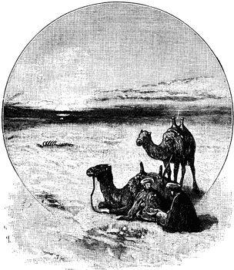
Geography of the Middle East

- The Middle East is a ______________________________ not a __________________________.
- It is mostly in ____________________, but also includes parts of _______________________ and _________________________________________.
- Most people in the Middle East practice ______________________ as their religion.
- A cultural region is: _________________________________________________________________________________________________________________
- A functional region is: _________________________________________________________________________________________________________________
Blank Map: Fill in below
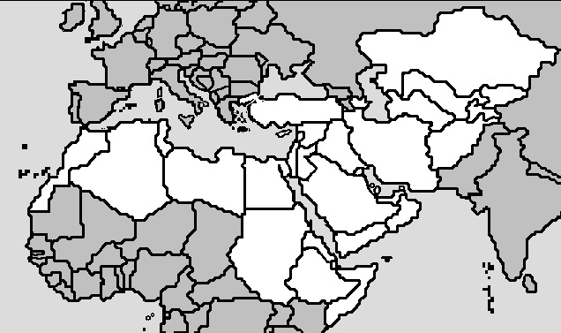
Map Skill Questions: Fill in below!

1. _______________________ 2. _________________________ 3. ___________________________
4. __________________________ 5. ___________________________ 6. ________________________

Video Comprehension Questions:

1. Why does the man, Michael Palin, say that this place in the Sahara desert seems like a big city? __________________________________________________________________________________________________________________________________________________________________________________________________________________________________________________
2. What kinds of things are going on during this weeklong festival? __________________________________________________________________________________________________________________________________________________________________________________________________________________________________________________
3. Who comes to this festival? What are their lifestyles like? __________________________________________________________________________________________________________________________________________________________________________________________________________________________________________________
Your Opinion and Knowledge Applied:

Why do you think the Tigris, Euphrates, and Nile Rivers are so important to the Middle East and its development? What advantages does starting a civilization here provide versus some place like the middle of the Sahara?
___________________________________________________________________________________________________________________________________________________________________________________________________________________________________________________________________________________________________________________________________________________________________________
While most see the Sahara as a baron and impossible place to live, what advantage do you think it can provide to those who brave the desert’s conditions and settle there?
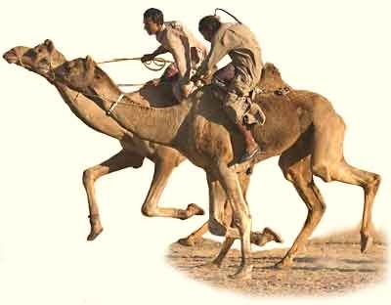
__________________________________________________________________________________________________________________________________________________________________________________________________________________
____________________________________________________________________________________
Why do we group the Middle East into one region when it covers parts of two separate continents?
________________________________________________________________________________________________________________________________________________________________________

