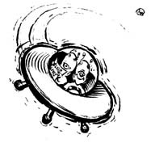
WebQuest Check List:
What will you find out there?

DAY 1: GEOGRAPHY AND LOCATION OF THE MIDDLE EAST.
EXPLORATION GUIDE: | CAPTAIN’S CLEARANCE
NOTES
BLANK MAP
QUIA GAME
MAP QUESTIONS
VIDEO QUESTIONS

DAY 2: RELIGIONS OF THE MIDDLE EAST
EXPLORATION GUIDE: | CAPTAIN’S CLEARANCE
RELIGION NOTES
JUDAISM
CHRISTIANITY
ISLAM
WORD SEARCH and Chart
Essay
DAY 3: THE PUSH FOR PEOPLE POWER
EXPLORATION GUIDE: | CAPTAIN’S CLEARANCE
ARAB SPRING NOTES
TUNISIA
EGYPT
SYRIA
ESSAY

GRADE: ____________________________
Captain’s Comments:

_______________________________________________________________________________________________________________________

